Project One
First Last
2024-05-05
Usage Notes
- System setup
  - Install quarto executable from https://quarto.org
- To compile report:
  - From the command line: quarto render reportTemplate.qmd
  - Inside RStudio: press Render from a recent RStudio
- Commenting/annotation/highlighting
  - If you have a free account with hypothes.is, will be placing the report on a permanent location on a web server, and want to enable highlighting, comments, and annotations by readers of the report, set hypothesis: true See https://quarto.org/docs/output-formats/html-basics.html#commenting
- Note on markdown tables
  - To keep markdown tables from devoting more space to a column than needed, make the second line of the table look like -|-|-|
  - Use require(qreport) to get the kabl function which makes it easy to combine multiple tables into one block
Thanks to Max Rohde for starting this template.
require(Hmisc)
require(qreport)
# Make base graphics look better:
spar <- function(bot=0, left=0, top=0, rt=0)
par(mar=c(3.25 + bot, 5 + left, 0.5 + top, 0.5 * rt),
lwd=1.75, mgp=c(2.0, 0.475, 0), tcl=-0.4, xpd=FALSE, ps=14,
cex.lab=1.15, cex.axis=0.8)
# Set abbreviations for chunk option names
knitr::set_alias(w = 'fig.width', h = 'fig.height')
# Get dataset from Dept of Biostatistics dataset repository
getHdata(pbc)
pbc[1:20, 1:8]
bili albumin stage protime sex fu.days age spiders
1 14.5 2.60 4 12.2 female 400 58.76523 present
2 1.1 4.14 3 10.6 female 4500 56.44627 present
3 1.4 3.48 4 12.0 male 1012 70.07255 absent
4 1.8 2.54 4 10.3 female 1925 54.74059 present
5 3.4 3.53 3 10.9 female 1504 38.10541 present
6 0.8 3.98 3 11.0 female 2503 66.25873 absent
7 1.0 4.09 3 9.7 female 1832 55.53457 absent
8 0.3 4.00 3 11.0 female 2466 53.05681 absent
9 3.2 3.08 2 11.0 female 2400 42.50787 present
10 12.6 2.74 4 11.5 female 51 70.55989 present
11 1.4 4.16 4 12.0 female 3762 53.71389 present
12 3.6 3.52 4 13.6 female 304 59.13758 present
13 0.7 3.85 3 10.6 female 3577 45.68925 absent
14 0.8 2.27 4 11.0 male 1217 56.22177 absent
15 0.8 3.87 3 11.0 female 3584 64.64613 absent
16 0.7 3.66 3 10.8 female 3672 40.44353 absent
17 2.7 3.15 4 10.5 female 769 52.18344 absent
18 11.4 2.80 4 12.4 female 131 53.93018 present
19 0.7 3.56 3 11.0 female 4232 49.56057 absent
20 5.1 3.51 4 13.0 female 1356 59.95346 absent
# Take two tables and produce one html section
kabl(pbc[1:20, 1:3], pbc[21:40, 1:4], caption='Two parts of `pbc` data frame')
Two parts of pbc data frame
bili | albumin | stage
14.5 | 2.60 | 4
1.1 | 4.14 | 3
1.4 | 3.48 | 4
1.8 | 2.54 | 4
3.4 | 3.53 | 3
0.8 | 3.98 | 3
1.0 | 4.09 | 3
0.3 | 4.00 | 3
3.2 | 3.08 | 2
12.6 | 2.74 | 4
1.4 | 4.16 | 4
3.6 | 3.52 | 4
0.7 | 3.85 | 3
0.8 | 2.27 | 4
0.8 | 3.87 | 3
0.7 | 3.66 | 3
2.7 | 3.15 | 4
11.4 | 2.80 | 4
0.7 | 3.56 | 3
5.1 | 3.51 | 4

 | bili | albumin | stage | protime
21 | 0.6 | 3.83 | 4 | 11.4
22 | 3.4 | 3.63 | 4 | 11.6
23 | 17.4 | 2.94 | 4 | 11.7
24 | 2.1 | 4.00 | 2 | 9.9
25 | 0.7 | 4.10 | 2 | 11.3
26 | 5.2 | 3.68 | 3 | 9.9
27 | 21.6 | 3.31 | 4 | 12.0
28 | 17.2 | 3.23 | 4 | 13.0
29 | 0.7 | 3.78 | 2 | 10.6
30 | 3.6 | 2.54 | 4 | 11.0
31 | 4.7 | 3.44 | 2 | 10.3
32 | 1.8 | 3.34 | 4 | 10.6
33 | 0.8 | 3.19 | 3 | 12.0
34 | 0.8 | 3.70 | 2 | 10.5
35 | 1.2 | 3.20 | 3 | 10.6
36 | 0.3 | 3.39 | 2 | 10.6
37 | 7.1 | 3.01 | 4 | 12.0
38 | 3.3 | 3.53 | 4 | 11.0
39 | 0.7 | 3.00 | 4 | 10.6
40 | 1.3 | 3.34 | 4 | 11.0

1. Descriptive Statistics
describe(pbc)
pbc
19 Variables 418 Observations
--------------------------------------------------------------------------------
bili : Serum Bilirubin (mg/dl)
n missing distinct Info Mean Gmd .05 .10
418 0 98 0.998 3.221 3.742 0.50 0.60
.25 .50 .75 .90 .95
0.80 1.40 3.40 8.03 14.00
lowest : 0.3 0.4 0.5 0.6 0.7 , highest: 21.6 22.5 24.5 25.5 28
--------------------------------------------------------------------------------
albumin : Albumin (gm/dl)
n missing distinct Info Mean Gmd .05 .10
418 0 154 1 3.497 0.473 2.750 2.967
.25 .50 .75 .90 .95
3.243 3.530 3.770 4.010 4.141
lowest : 1.96 2.1 2.23 2.27 2.31, highest: 4.3 4.38 4.4 4.52 4.64
--------------------------------------------------------------------------------
stage : Histologic Stage, Ludwig Criteria
n missing distinct Info Mean Gmd
412 6 4 0.893 3.024 0.9519
Value 1 2 3 4
Frequency 21 92 155 144
Proportion 0.051 0.223 0.376 0.350
For the frequency table, variable is rounded to the nearest 0
--------------------------------------------------------------------------------
protime : Prothrombin Time (sec.)
n missing distinct Info Mean Gmd .05 .10
416 2 48 0.998 10.73 1.029 9.60 9.80
.25 .50 .75 .90 .95
10.00 10.60 11.10 12.00 12.45
lowest : 9 9.1 9.2 9.3 9.4 , highest: 13.8 14.1 15.2 17.1 18
--------------------------------------------------------------------------------
sex
n missing distinct
418 0 2
Value male female
Frequency 44 374
Proportion 0.105 0.895
--------------------------------------------------------------------------------
fu.days : Time to Death or Liver Transplantation
n missing distinct Info Mean Gmd .05 .10
418 0 399 1 1918 1253 245.1 606.8
.25 .50 .75 .90 .95
1092.8 1730.0 2613.5 3524.2 4040.6
lowest : 41 43 51 71 77, highest: 4500 4509 4523 4556 4795
--------------------------------------------------------------------------------
age : Age
n missing distinct Info Mean Gmd .05 .10
418 0 345 1 50.74 11.96 33.84 36.37
.25 .50 .75 .90 .95
42.83 51.00 58.24 64.30 67.92
lowest : 26.2779 28.8843 29.5551 30.2752 30.5736
highest: 74.5243 75 75.0116 76.7091 78.4394
--------------------------------------------------------------------------------
spiders
n missing distinct
312 106 2
Value absent present
Frequency 222 90
Proportion 0.712 0.288
--------------------------------------------------------------------------------
hepatom
n missing distinct
312 106 2
Value absent present
Frequency 152 160
Proportion 0.487 0.513
--------------------------------------------------------------------------------
ascites
n missing distinct
312 106 2
Value absent present
Frequency 288 24
Proportion 0.923 0.077
--------------------------------------------------------------------------------
alk.phos : Alkaline Phosphatase (U/liter)
n missing distinct Info Mean Gmd .05 .10
312 106 295 1 1983 1760 599.6 663.0
.25 .50 .75 .90 .95
871.5 1259.0 1980.0 3826.4 6669.9
lowest : 289 310 369 377 414
highest: 11046.6 11320.2 11552 12258.8 13862.4
--------------------------------------------------------------------------------
sgot : SGOT (U/ml)
n missing distinct Info Mean Gmd .05 .10
312 106 179 1 122.6 60.45 54.25 60.45
.25 .50 .75 .90 .95
80.60 114.70 151.90 196.47 219.25
lowest : 26.35 28.38 41.85 43.4 45 , highest: 288 299.15 328.6 338 457.25
--------------------------------------------------------------------------------
chol : Cholesterol (mg/dl)
n missing distinct Info Mean Gmd .05 .10
284 134 201 1 369.5 194.5 188.4 213.6
.25 .50 .75 .90 .95
249.5 309.5 400.0 560.8 674.0
lowest : 120 127 132 149 151, highest: 1336 1480 1600 1712 1775
--------------------------------------------------------------------------------
trig : Triglycerides (mg/dl)
n missing distinct Info Mean Gmd .05 .10
282 136 146 1 124.7 64.07 56.00 63.10
.25 .50 .75 .90 .95
84.25 108.00 151.00 195.00 230.95
lowest : 33 44 46 49 50, highest: 319 322 382 432 598
--------------------------------------------------------------------------------
platelet : Platelets (per cm^3/1000)
n missing distinct Info Mean Gmd .05 .10
308 110 210 1 261.9 107.8 117.7 139.7
.25 .50 .75 .90 .95
199.8 257.0 322.5 386.5 430.6
lowest : 62 70 71 79 80, highest: 493 514 518 539 563
--------------------------------------------------------------------------------
drug
n missing distinct
418 0 3
Value D-penicillamine placebo not randomized
Frequency 154 158 106
Proportion 0.368 0.378 0.254
--------------------------------------------------------------------------------
status : Follow-up Status
n missing distinct Info Sum Mean Gmd
418 0 2 0.71 161 0.3852 0.4748
--------------------------------------------------------------------------------
edema
n missing distinct
418 0 3
Value no edema edema, no diuretic therapy
Frequency 354 44
Proportion 0.847 0.105
Value edema despite diuretic therapy
Frequency 20
Proportion 0.048
--------------------------------------------------------------------------------
copper : Urine Copper (ug/day)
n missing distinct Info Mean Gmd .05 .10
310 108 158 1 97.65 83.16 17.45 24.00
.25 .50 .75 .90 .95
41.25 73.00 123.00 208.10 249.20
lowest : 4 9 10 11 12, highest: 412 444 464 558 588
--------------------------------------------------------------------------------
A marginal note goes here. It can be as long as you want and can include raw R output.
spar(top=1) # allow for title (title produced by default by hist)
with(pbc, hist(albumin, nclass=30))
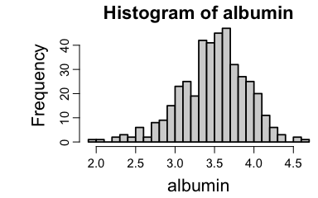
Histogram of serum albumin
# To just use the caption in the margin, use spar() and hist(..., main='')
Quarto has a nice way of letting you lay out plots. In the following example layout: [[1,1], [1]] in the chunk header specifies that there are two rows of plots, with the first row containing two plots and the second only one, with the one made wider to fill the whole space.
with(pbc, {
spar()
plot(bili, albumin)
plot(albumin, protime)
hist(albumin, nclass=25, main='') } )
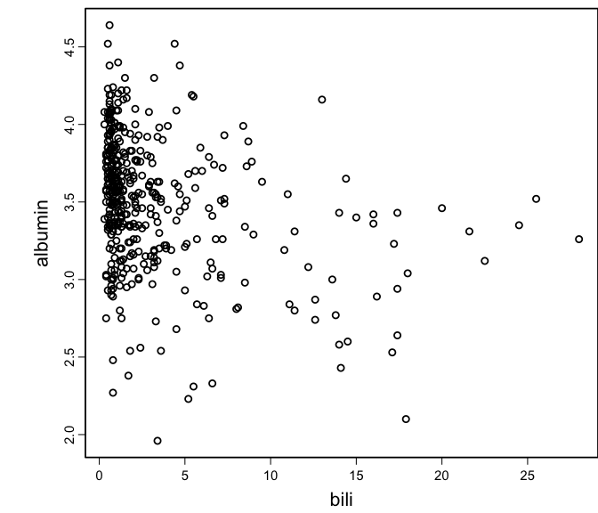 | 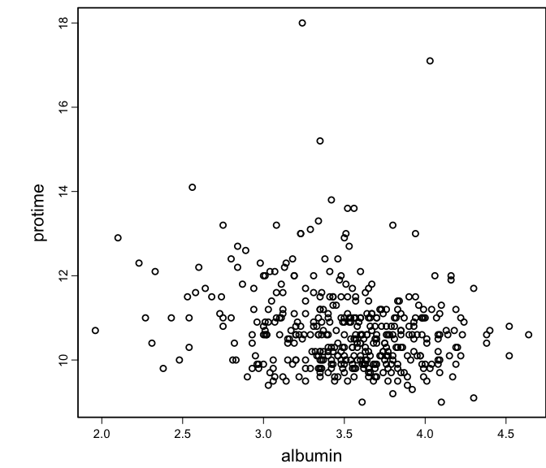

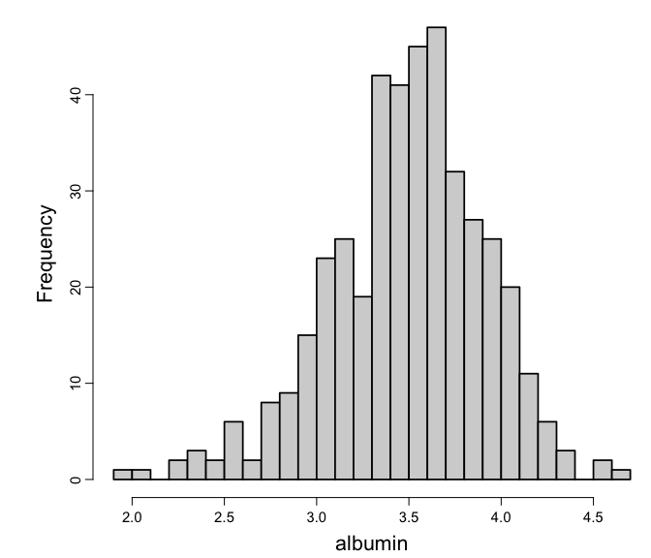

2. Running quarto
The yaml header in this template will cause both html and pdf files (throught LaTeX) to be produced. To only produce one output format, run e.g. quarto render my.qmd --to html.
To make your script dual-purpose you can’t always reliably use marginal notes in LaTeX using this quarto syntax:
some text … some text …
So automatically sense which output format is being created and create a character string that will work for both html and LaTeX. For LaTeX, a boxed note in the body of the document will appear.
ishtml <- knitr::is_html_output()
mNote <- if(ishtml) '.column-margin' else '.callout-note appearance="minimal"'
Then use
# Make a temporary mNote string for illustration
mNote <- '.callout-note appearance="minimal"'
some text … some text …

3. Computing Environment

See this for more information

